NYHS Exhibit Fêtes Ludwig Bemelmans and Madeline on Her 75th Anniversary
July 8, 2014 7:35 AM

Nancy Lazarus heads up Central Park West covered in vines, in search of twelve little girls in two straight lines, or at least the smallest one of the bunch: Madeline, and her creator.

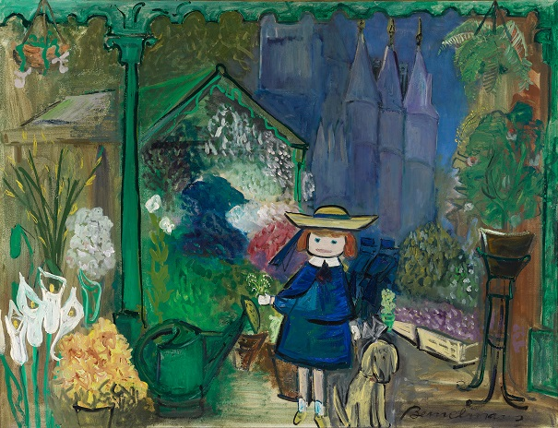
Madeline at the Paris Flower Market, 1955. Courtesy the Estate of Ludwig Bemelmans.

As a hotelier, cartoonist, and fabric designer, Ludwig Bemelmans was a jack of all trades, butMadeline, published in 1939, became his masterpiece. The New York Historical Society is marking the 75th anniversary with a retrospective of his career. “Madeline in New York: The Art of Ludwig Bemelmans,” is on view through October 19.

“He took any jobs that came along,” said exhibition curator Jane Bayard Curley of the Eric Carle Museum of Picture Book Art in Amherst, Massachusetts, the show’s organizer. Over 100 works are on display, reflecting Bemelmans’ many talents: drawings, paintings, manuscripts, photographs, and specially commissioned objects, including murals for the playroom of Christina, the Onassis yacht. Bemelmans’ family opened their archives to lend artwork and memorabilia.

“We created a faux Bemelmans’ Bar, but don’t tell the Carlyle,” joked Charles Royce, who along with his wife Deborah, lent murals from their luxury hotel, Ocean House in Watch Hill, Rhode Island. They acquired six plaster works, which had once graced the walls of Bemelmans’ La Colombe bistro in Paris. Royce was referring of course to New York’s Carlyle Hotel, where Bemelmans painted murals depicting the seasons of Central Park.
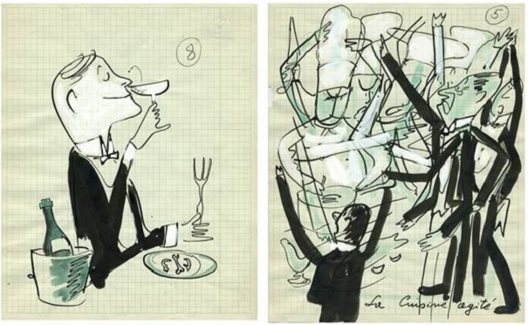
Pictured from left, “By applying myself thoroughly to the study of kitchen and the cellar” and “Interesting as the hotel was, my ambition was to paint,” both from “Adieu to the Old Ritz,” which appeared in the December 1950 issue of Town & Country.
Though Bemelmans later became known as a bon vivant, he weathered ups and downs. Born in Europe, he immigrated to New York in 1914, and started as a busboy at the Ritz Hotel. “The hotel business was his solace, and he mined this experience, becoming a chronicler of stories for kids and adults,” Curley said. “He was a self-taught painter and used empty spaces in the hotel as his studio.” Bathtubs and trains were among his other favorite creative spots.
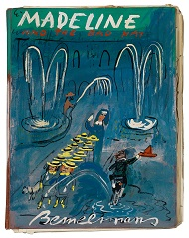After a Viking editor suggested he create children’s books, Bemelmans obliged. As for the Madeline character, “She’s a little bit of me, my mother, my wife and [daughter], Barbara. She’s a concoction of people,” Bemelmans once said. He created the French schoolgirl while at Pete’s Tavern in Gramercy Park, and it gave him great comfort. “For me, Madeline is therapy in the dark hours.” He wrote a series of Madeline books, and after his death, the mantle passed to his grandson, John Bemelmans Marciano, who became a Madeline author in his own right.

Being a cartoonist was one of Bemelmans’ earlier career ambitions, and “Adieu to the Old Ritz” is a set of illustrations he created after the hotel closed to accompany a Town & Country article. It serves as the story of his life. There he was called “Monsieur Louis,” and as Curley noted, “He took difficult situations and made them funny.” His hotel-related escapades involved steering a roaring ’20s car because his chauffeur didn’t know how to drive, and dealing with an “evil” secretary who tattled on his whereabouts.
Still, it was Madeline who brought Bemelmans the most acclaim, and as Curley commented, “It was the artistic transformation of his experience.” We noticed a Madeline painting with a caption that will likely sum up many visitors’ reactions to the exhibit: “In they walked and then said Ahhh.”
Writer Nancy Lazarus is a frequent contributor to UnBeige.

